**EX:02-Create a simple cloud software application for Flight Reservation System**

**using any Cloud Service Provider to demonstrate SaaS.**

**Aim**

To Create a simple cloud software application for Flight Reservation System using any Cloud Service Provider to demonstrate SaaS.

**Procedure**

* **Login to Zoho Creator** – Use your account credentials to sign in and enter the Zoho Creator platform.
* **Start Building an App** – Click “Create Application” and decide whether to use a ready-made template or begin with a blank one.
* **Create Forms & Modules** – Design forms (like customer details, property/booking info) and add the required fields.
* **Add Workflows & Rules** – Set up automation, validations, and logic to manage user actions smoothly.
* **Launch the App** – Save your work and publish the app on Zoho’s cloud system.
* **Enable SaaS Usage** – Share the app’s URL so that users can access and use it online as a SaaS solution.

**Output**

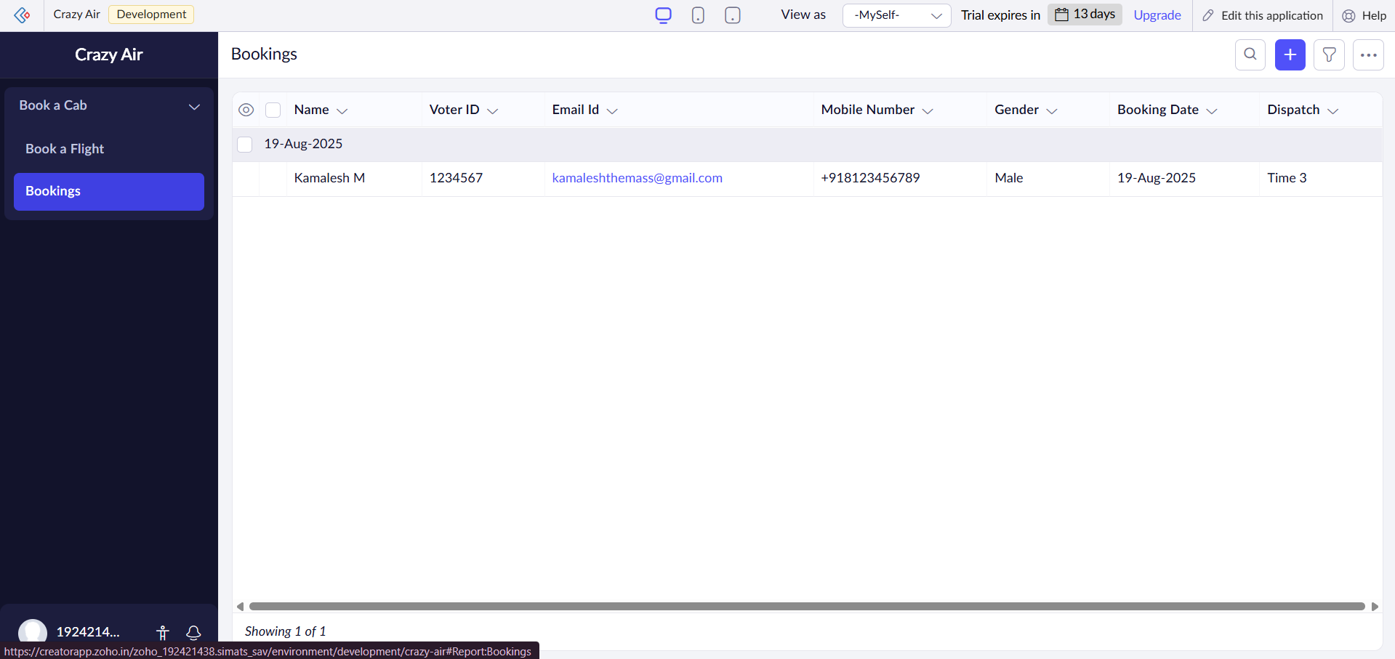

**Result**

Thus, a simple cloud software application for Flight Reservation System was successfully created and deployed using Zoho Creator, and it was provided as a Software as a Service (SaaS) model.